From: Belogrud Sergey Vladimirovich
Sent: Monday, September 21, 2015 7:38 PM
To: Meagcov Vitalie
Cc: oradba; unix-admins
Subject: RE: [JIRA] (ITP-1072) установить платы pci-ssd-6TB в сервера oracle

Все 100% диска отданы под один раздел 6400GB.

[root@ds-db-tst ~]# parted /dev/fioa print
Model: Unknown (unknown)
Disk /dev/fioa: 6400GB
Sector size (logical/physical): 4096B/4096B
Partition Table: gpt

Number Start End Size File system Name Flags
1 1049kB 6400GB 6400GB primary

[root@ds-db-tst ~]#

Освобождение зарезервированных на случай переполнения файловой системы блоков, ситуацию в целом оставило прежней (это не 5% резерва в ext4 – это xfs).
[root@ds-db-tst ~]# xfs_io -x -c "resblks" /mnt/fioa1
reserved blocks = 8192
available reserved blocks = 8192
[root@ds-db-tst ~]#

[root@ds-db-tst ~]# df /mnt/fioa1
Filesystem 1K-blocks Used Available Use% Mounted on
/dev/fioa1 6247911296 34208 6247877088 1% /mnt/fioa1
[root@ds-db-tst ~]# df -h /mnt/fioa1
Filesystem Size Used Avail Use% Mounted on
/dev/fioa1 5.9T 34M 5.9T 1% /mnt/fioa1
[root@ds-db-tst ~]#

[root@ds-db-tst ~]# xfs_io -x -c "resblks 0" /mnt/fioa1
reserved blocks = 0
available reserved blocks = 0
[root@ds-db-tst ~]#

[root@ds-db-tst ~]# df /mnt/fioa1
Filesystem 1K-blocks Used Available Use% Mounted on
/dev/fioa1 6247911296 1440 6247909856 1% /mnt/fioa1
[root@ds-db-tst ~]# df -h /mnt/fioa1
Filesystem Size Used Avail Use% Mounted on
/dev/fioa1 5.9T 1.5M 5.9T 1% /mnt/fioa1
[root@ds-db-tst ~]#

Так, что микросхемы похоже на месте. J

From: Meagcov Vitalie
Sent: Monday, September 21, 2015 6:33 PM
To: Belogrud Sergey Vladimirovich
Cc: oradba; unix-admins
Subject: RE: [JIRA] (ITP-1072) установить платы pci-ssd-6TB в сервера oracle
Importance: Low

Где пол-терабайта? J
Верни микросхему!

From: Belogrud Sergey Vladimirovich
Sent: Monday, September 21, 2015 6:14 PM
To: Meagcov Vitalie
Cc: oradba; unix-admins
Subject: RE: [JIRA] (ITP-1072) установить платы pci-ssd-6TB в сервера oracle

На сервере ds-db-tst смонтирован PCIe SSD диск в каталог /mnt/fioa1.
Cоздан подкаталог oracle который можно использовать для целей тестирования (даны права для пользователя oracle и группы oinstall).

[root@ds-db-tst 20150921-1635]# df -h /mnt/fioa1
Filesystem Size Used Avail Use% Mounted on
/dev/fioa1 5.9T 34M 5.9T 1% /mnt/fioa1
[root@ds-db-tst 20150921-1635]#

[root@ds-db-tst 20150921-1635]# ls -Alhd /mnt/fioa1/oracle/
drwxr-xr-x 2 oracle oinstall 6 Sep 21 18:03 /mnt/fioa1/oracle/
[root@ds-db-tst 20150921-1635]#

Можно приступать к тестированию.

20150914
How to get information about raid array config from all servers

[root@ds-gp-prd-smdw ~]# for var1 in mdw smdw sdw{1..16} ; do ssh ${var1} "( hostname ; dmidecode -t system | grep -i -e Product\ Name -e Serial ; cd /tmp/ ; hpssascripting -c $(pwd)/$(date +%Y%m%d-%H%M).hpssascripting.dat ; grep -e Controller -e StripSize $(pwd)/$(date +%Y%m%d-%H%M).hpssascripting.dat )" ; done

File System Layout Calculator
https://access.redhat.com/labs/fslayoutcalculator/

20150710

Here is an example with our GreenPlum partitions.
What we have and what recommends RedHat.

[root@hq-msk-gp-tst-sdw2 20150710-1903]# hpssascripting -c $(pwd)/$(date +%Y%m%d-%H%M).hpssascripting.dat
[root@hq-msk-gp-tst-sdw2 20150710-1903]# ll
total 4
-rw-r--r-- 1 root root 2008 Jul 10 19:04 20150710-1904.hpssascripting.dat
[root@hq-msk-gp-tst-sdw2 20150710-1903]# cat 20150710-1904.hpssascripting.dat
; Date captured: Fri Jul 10 19:04:45 2015

; Version: 2.0.23.0

Action= Configure
Method= Custom

; Controller Specifications
; Controller HP Smart Array P410i, FirmwareVersion 6.64, License Keys Supported
; SerialNumber 5001438009BD5390
; DriverName hpsa
; DriverVersion 3.4.4
; SSDSmartPath Not Supported
Controller= SLOT 0
ReadCache= 0
WriteCache= 100
RebuildPriority= Medium
ExpandPriority= Medium
SurfaceScanMode= Idle
SurfaceScanDelay= 15
DriveWriteCache= Enabled
NoBatteryWriteCache= Enabled

; Array Specifications
Array= A
; Array Drive Type is SAS
; Array Free Space 704 KB
; 1I:1:1 (600.1 GB, SAS), 1I:1:2 (600.1 GB, SAS), 1I:1:3 (600.1 GB, SAS), 1I:1:4 (600.1 GB, SAS), 2I:1:5 (600.1 GB, SAS), 2I:1:6 (600.1 GB, SAS), 2I:1:7 (600.1 GB, SAS), 2I:1:8 (600.1 GB, SAS)
Drive= 1I:1:1, 1I:1:2, 1I:1:3, 1I:1:4, 2I:1:5, 2I:1:6, 2I:1:7, 2I:1:8
OnlineSpare= No

; Logical Drive Specifications
LogicalDrive= 1
RAID= 5
Size= 4006056
; SizeBlocks= 8204403632
Sectors= 63
StripSize= 128
Caching= Enabled
; VolumeUniqueID= 600508B1001C335900FEA31CF6145EF5

; Controller Specifications
; Controller HP Smart Array P410, FirmwareVersion 6.64, License Keys Supported
; SerialNumber PACCRID11320CZ8
; DriverName hpsa
; DriverVersion 3.4.4
; SSDSmartPath Not Supported
Controller= SLOT 1
ReadCache= 0
WriteCache= 100
RebuildPriority= Medium
ExpandPriority= Medium
SurfaceScanMode= Idle
SurfaceScanDelay= 15
DriveWriteCache= Enabled
NoBatteryWriteCache= Enabled

; Array Specifications
Array= A
; Array Drive Type is SAS
; Array Free Space 704 KB
; 1I:1:1 (600.1 GB, SAS), 1I:1:2 (600.1 GB, SAS), 1I:1:3 (600.1 GB, SAS), 1I:1:4 (600.1 GB, SAS), 2I:1:5 (600.1 GB, SAS), 2I:1:6 (600.1 GB, SAS), 2I:1:7 (600.1 GB, SAS), 2I:1:8 (600.1 GB, SAS)
Drive= 1I:1:1, 1I:1:2, 1I:1:3, 1I:1:4, 2I:1:5, 2I:1:6, 2I:1:7, 2I:1:8
OnlineSpare= No

; Logical Drive Specifications
LogicalDrive= 1
RAID= 5
Size= 4006056
; SizeBlocks= 8204403632
Sectors= 63
StripSize= 128
Caching= Enabled
; VolumeUniqueID= 600508B1001C7CBE9AE98973D61B7283
[root@hq-msk-gp-tst-sdw2 20150710-1903]#

[root@hq-msk-gp-tst-sdw2 20150710-1903]# man mkfs.xfs
...
-b block_size_options
This option specifies the fundamental block size of the filesystem. The valid block_size_options are: log=value or size=value and only one can be supplied. The block size
is specified either as a base two logarithm value with log=, or in bytes with size=. The default value is 4096 bytes (4 KiB), the minimum is 512, and the maximum is 65536
(64 KiB). XFS on Linux currently only supports pagesize or smaller blocks.

-d data_section_options
These options specify the location, size, and other parameters of the data section of the filesystem. The valid data_section_options are:
...
sunit=value
This is used to specify the stripe unit for a RAID device or a logical volume. The value has to be specified in 512-byte block units. Use the su suboption to
specify the stripe unit size in bytes. This suboption ensures that data allocations will be stripe unit aligned when the current end of file is being extended and
the file size is larger than 512KiB. Also inode allocations and the internal log will be stripe unit aligned.

su=value
This is an alternative to using sunit. The su suboption is used to specify the stripe unit for a RAID device or a striped logical volume. The value has to be
specified in bytes, (usually using the m or g suffixes). This value must be a multiple of the filesystem block size.

swidth=value
This is used to specify the stripe width for a RAID device or a striped logical volume. The value has to be specified in 512-byte block units. Use the sw subop-
tion to specify the stripe width size in bytes. This suboption is required if -d sunit has been specified and it has to be a multiple of the -d sunit suboption.

sw=value
suboption is an alternative to using swidth. The sw suboption is used to specify the stripe width for a RAID device or striped logical volume. The value is
expressed as a multiplier of the stripe unit, usually the same as the number of stripe members in the logical volume configuration, or data disks in a RAID
device.

Here is what we have.
[root@hq-msk-gp-tst-sdw2 20150710-1903]# lsblk
NAME MAJ:MIN RM SIZE RO TYPE MOUNTPOINT
sda 8:0 0 3.8T 0 disk
├─sda1 8:1 0 1000M 0 part /boot
├─sda2 8:2 0 3.4T 0 part /data1
├─sda3 8:3 0 304.7G 0 part /work1
└─sda4 8:4 0 46.9G 0 part /
sdb 8:16 0 3.8T 0 disk
├─sdb1 8:17 0 3.4T 0 part /data2
├─sdb2 8:18 0 304.7G 0 part /work2
└─sdb3 8:19 0 125G 0 part [SWAP]
[root@hq-msk-gp-tst-sdw2 20150710-1903]# xfs_info /dev/sda2
meta-data=/dev/sda2 isize=256 agcount=4, agsize=227840000 blks
= sectsz=512 attr=2, projid32bit=0
data = bsize=4096 blocks=911360000, imaxpct=5
= sunit=0 swidth=0 blks
naming =version 2 bsize=4096 ascii-ci=0
log =internal bsize=4096 blocks=445000, version=2
= sectsz=512 sunit=0 blks, lazy-count=1
realtime =none extsz=4096 blocks=0, rtextents=0
[root@hq-msk-gp-tst-sdw2 20150710-1903]#

But here is what recommends RedHat!
#mkfs.xfs -b 4096 -d su=128k,sw=7 /dev/mydevice
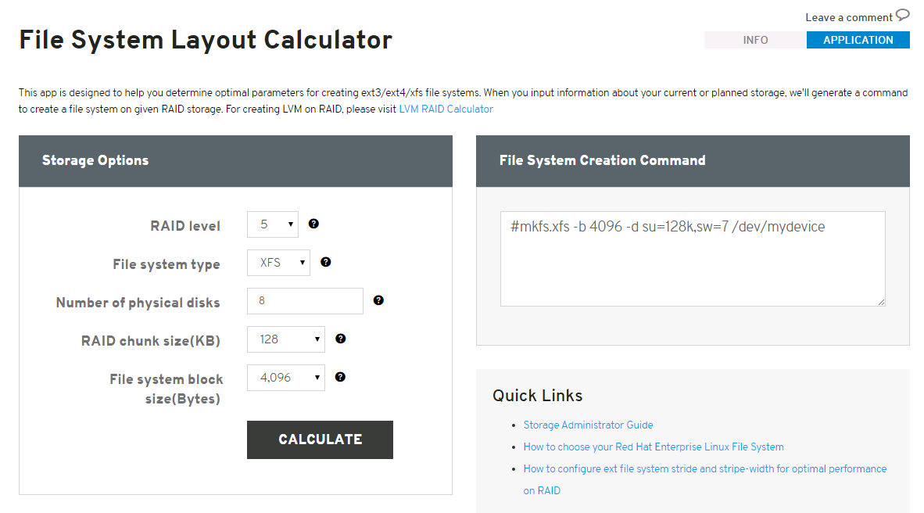
RAID level

Select which RAID level to use. When in doubt, select 5, which is the most common type.
Storage Administrator Guide

File system type

Depending on your business requirements, you may use different types. If both your server and your storage device are large, XFS is likely to be the best choice. If your existing workload has performed well with ext3, stay with ext3 on RHEL5 or migrate to ext4 on RHEL6.
How to choose your Red Hat Enterprise Linux File System

Number of physical disks

Specify the number of physical disks you plan to use. Do not include hot spare disks - preparatory disk drives that are kept on active standby for use when a disk drive fails.

RAID chunk size

Chunk size is a property of the RAID array. It specifies the smallest "atomic" mass of data that can be written to the devices. Chunk size is set either in the local RAID controller's BIOS, or on the SAN when the array is created. To determine the chunk size, either check your RAID BIOS, or consult your SAN administrator.

File system block size

File system block size specifies size that the file system will use to read and write data. We recommend you use 4096(4KB) for all of ext3, ext4 and XFS. In XFS, files are allocated in extents (a group of blocks which are treated as one big block), so there is no performance penalty to use 4KB block size vs larger block sizes like 64KB.

And look at this.
Here is an option to create file-systems for OS in same conditions.
This is how to should be created file-systems for OS on GreenPlum servers…
#mkfs.ext4 -b 4096 -E stride=32,stripe-width=224 /dev/mydevice

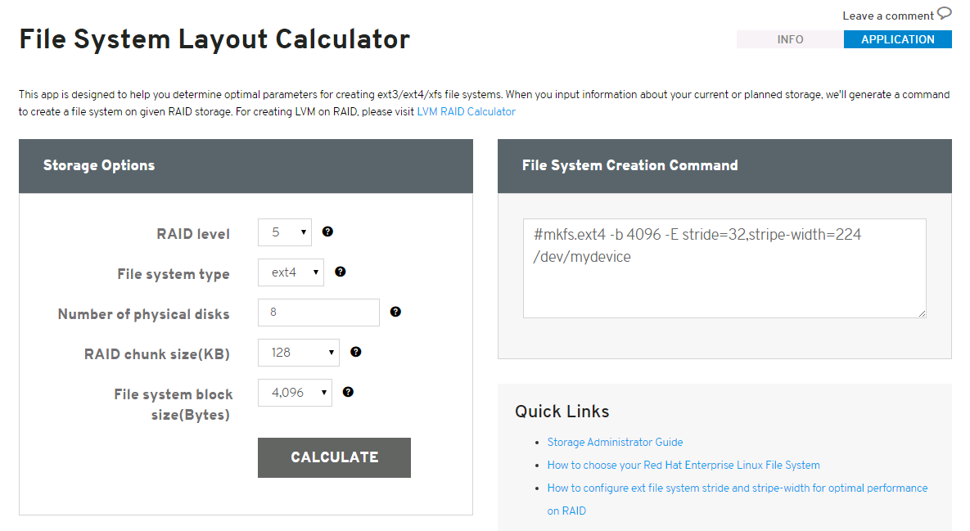

Here is my configuration file for raid array thay looks like GreenPlum raid array.
[root@centos00 scripts]# cat hpssascripting.raid5.any_controllers.all_drives.no_spare.dat

action= configure
method= custom

controller= all

readcache= 10
writecache= 90

rebuildpriority= medium
expandpriority= medium

surfacescanmode= idle
surfacescandelay= 15

drivewritecache= enabled
nobatterywritecache= disabled

array= next
drive= *
logicaldrive= next
raid= 5
; I'm not sure about next option. I hope it will be universal for most cases. Even if capacity is less than 2TB.
size= max
caching= enabled

[root@centos00 scripts]#

https://access.redhat.com/labs/fslayoutcalculator/

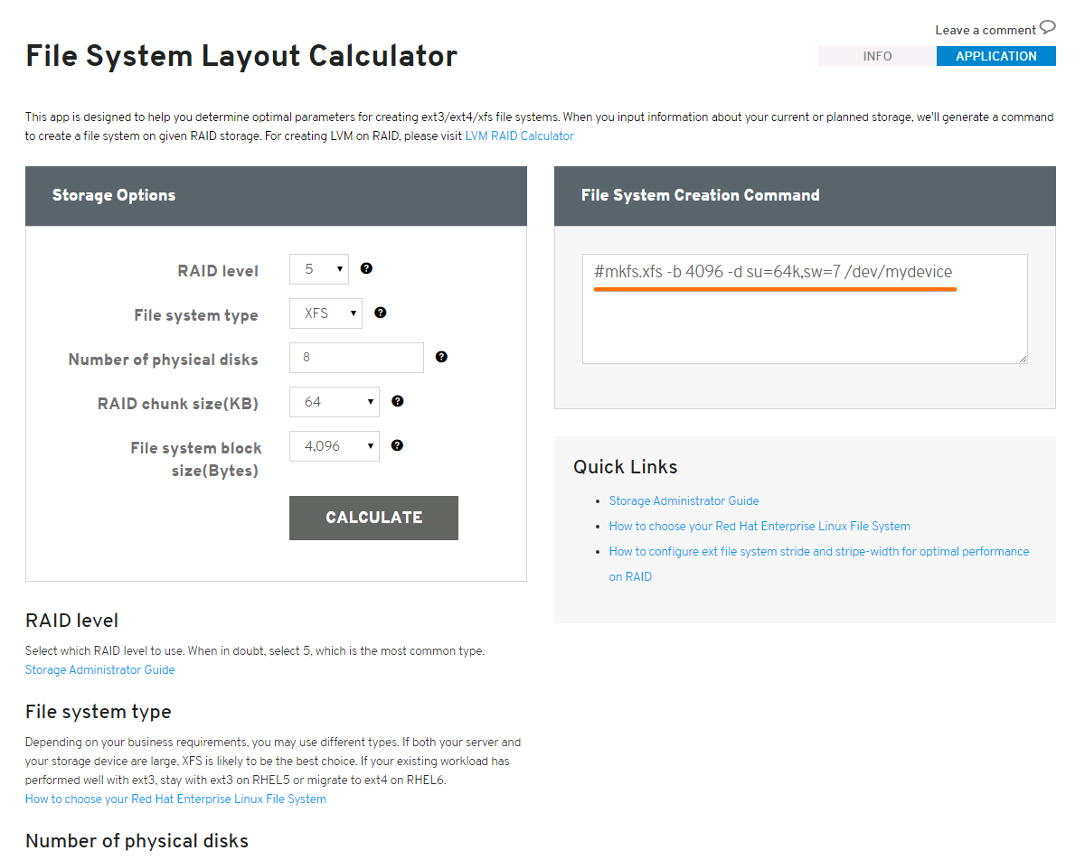

RAID level

Select which RAID level to use. When in doubt, select 5, which is the most common type.
Storage Administrator Guide

File system type

Depending on your business requirements, you may use different types. If both your server and your storage device are large, XFS is likely to be the best choice. If your existing workload has performed well with ext3, stay with ext3 on RHEL5 or migrate to ext4 on RHEL6.
How to choose your Red Hat Enterprise Linux File System

Number of physical disks

Specify the number of physical disks you plan to use. Do not include hot spare disks - preparatory disk drives that are kept on active standby for use when a disk drive fails.

RAID chunk size

Chunk size is a property of the RAID array. It specifies the smallest "atomic" mass of data that can be written to the devices. Chunk size is set either in the local RAID controller's BIOS, or on the SAN when the array is created. To determine the chunk size, either check your RAID BIOS, or consult your SAN administrator.

File system block size

File system block size specifies size that the file system will use to read and write data. We recommend you use 4096(4KB) for all of ext3, ext4 and XFS. In XFS, files are allocated in extents (a group of blocks which are treated as one big block), so there is no performance penalty to use 4KB block size vs larger block sizes like 64KB.

From: Alexey Grishchenko [mailto:agrishchenko@pivotal.io]
Sent: Thursday, July 16, 2015 1:28 PM
To: Pavlov Dmitriy Stanislavovich
Cc: Belogrud Sergey Vladimirovich; greenplum_admins
Subject: Re: И ещё раз об xfs

По сути su и sw говорят файловой системе о том, чему равен страйп вашего RAID-массива и сколько дисков в нем. sw=4, потому что у вас 8 дисков в RAID10, то есть по сути 4 диска данных. su=32k говорит, что страйп вашего RAID-массива равен 32KB.
То есть указанные параметры на мой взгляд правильные
И это не отменяет факта, что raid chunk size должен быть выставлен в 32k

Вообще, моя рекомендация вам - погоняйте бенчмарки c разными настройками raid chunk и xfs. Это не займет больше дня, зато результаты будут релевантны именно для вашей системы

On Thu, Jul 16, 2015 at 11:02 AM, Pavlov Dmitriy Stanislavovich <d.s.pavlov@tinkoff.ru> wrote:
Лёш, нужна ещё небольшая консультация.
RH недавно запилил калькулятор параметров для разных ФС:
https://access.redhat.com/labs/fslayoutcalculator/ (нужен аккаунт в RH, даже уровня personal подойдёт).
Например, для нашей будущей конфигурации:
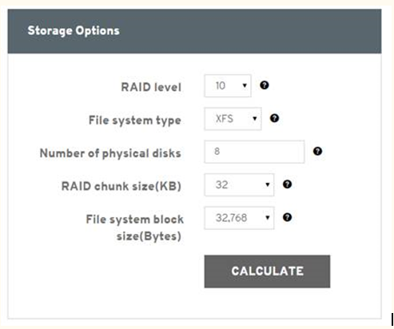

Оно советует так:

#mkfs.xfs -b 32768 -d su=32k,sw=4 /dev/mydevice

Собственно, есть несколько вопросов:
1. Что скажешь про sw=4
2. Что скажешь про RAID Chunk Size (который, судя по всему, всегда равен su)? Стоит ли его ставить равным размеру блока ГП (32К)?
Для справки:

-d data_section_options
These options specify the location, size, and other parameters of the data section of the filesystem. The valid data_section_options are:
...
sunit=value
This is used to specify the stripe unit for a RAID device or a logical volume. The value has to be specified in 512-byte block units. Use the su suboption to
specify the stripe unit size in bytes. This suboption ensures that data allocations will be stripe unit aligned when the current end of file is being extended and
the file size is larger than 512KiB. Also inode allocations and the internal log will be stripe unit aligned.

su=value
This is an alternative to using sunit. The su suboption is used to specify the stripe unit for a RAID device or a striped logical volume. The value has to be
specified in bytes, (usually using the m or g suffixes). This value must be a multiple of the filesystem block size.

swidth=value
This is used to specify the stripe width for a RAID device or a striped logical volume. The value has to be specified in 512-byte block units. Use the sw subop-
tion to specify the stripe width size in bytes. This suboption is required if -d sunit has been specified and it has to be a multiple of the -d sunit suboption.

sw=value
suboption is an alternative to using swidth. The sw suboption is used to specify the stripe width for a RAID device or striped logical volume. The value is
expressed as a multiplier of the stripe unit, usually the same as the number of stripe members in the logical volume configuration, or data disks in a RAID
device.

С уважением,
Дмитрий Павлов
Администратор DWH

--
Best regards,
Alexey Grishchenko
Pivotal Enterprise Architect (EMEA)
office: +353 (21) 423 8112
mobile: +353 (87) 262 2154
e-mail: AGrishchenko@pivotal.io

20160622
# Example of options for raid 10 and 4 HDD.
#mkfs.xfs -b 4096 -d su=64k,sw=2 /dev/mydevice
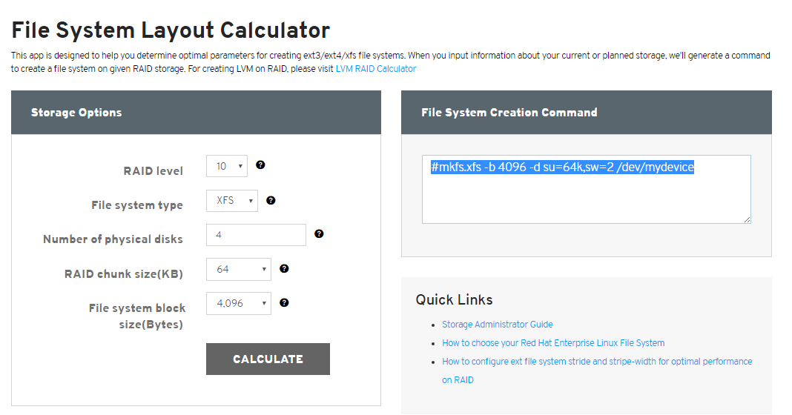

# When I tried to format partition on rhel 7.2, I have gotten follow error:
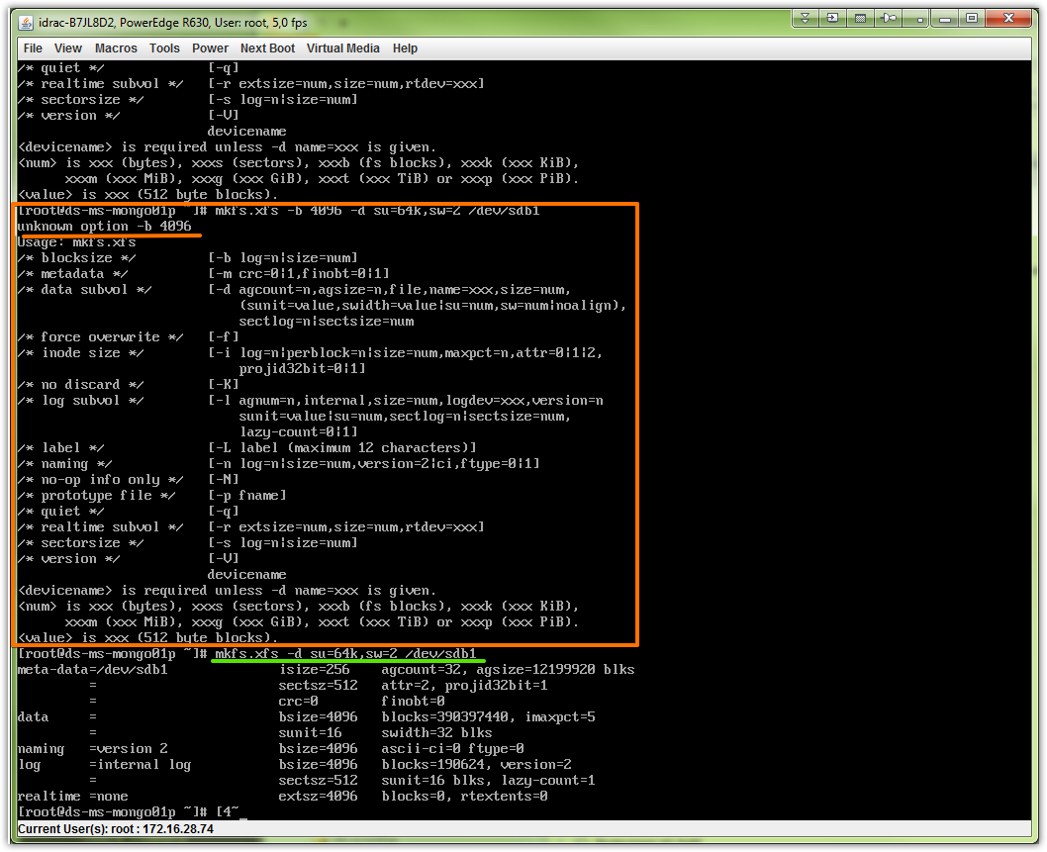

20170317

# Here is we have 10 HDD, with raid 5 and used under rhel 6.
# Below I have created xfs partition on these drives.

[root@m1-gp-prd-bkp1 ~]# yum localinstall http://repo-linux/others/xfsprogs/xfsprogs-3.1.1-6.el6.x86_64.rpm

[root@m1-gp-prd-bkp1 ~]# parted -a optimal /dev/sdd mklabel GPT print mkpart primary xfs 0% 100% print
Model: DELL PERC H730P Mini (scsi)
Disk /dev/sdd: 72.0TB
Sector size (logical/physical): 512B/4096B
Partition Table: gpt

Number Start End Size File system Name Flags

Model: DELL PERC H730P Mini (scsi)
Disk /dev/sdd: 72.0TB
Sector size (logical/physical): 512B/4096B
Partition Table: gpt

Number Start End Size File system Name Flags
1 1049kB 72.0TB 72.0TB primary

Information: You may need to update /etc/fstab.

[root@m1-gp-prd-bkp1 ~]#

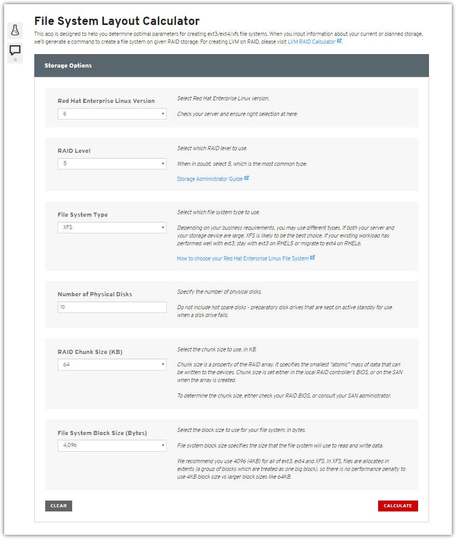
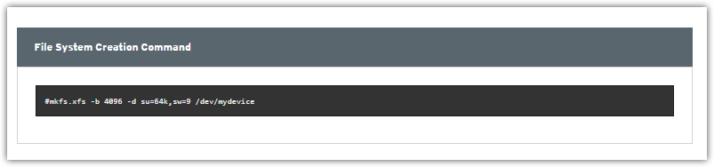

# I should use follow command string.
# mkfs.xfs -b 4096 -d su=64k,sw=9 /dev/mydevice
# But it returns error during I run it.
[root@m1-gp-prd-bkp1 ~]# mkfs.xfs -b 4096 -d su=64k,sw=9 /dev/sdd1
unknown option -b 4096
Usage: mkfs.xfs
/* blocksize */ [-b log=n|size=num]
/* data subvol */ [-d agcount=n,agsize=n,file,name=xxx,size=num,
(sunit=value,swidth=value|su=num,sw=num),
sectlog=n|sectsize=num
/* inode size */ [-i log=n|perblock=n|size=num,maxpct=n,attr=0|1|2]
/* log subvol */ [-l agnum=n,internal,size=num,logdev=xxx,version=n
sunit=value|su=num,sectlog=n|sectsize=num,
lazy-count=0|1]
/* label */ [-L label (maximum 12 characters)]
/* naming */ [-n log=n|size=num,version=2|ci]
/* prototype file */ [-p fname]
/* quiet */ [-q]
/* realtime subvol */ [-r extsize=num,size=num,rtdev=xxx]
/* sectorsize */ [-s log=n|size=num]
/* version */ [-V]
devicename
<devicename> is required unless -d name=xxx is given.
<num> is xxx (bytes), xxxs (sectors), xxxb (fs blocks), xxxk (xxx KiB),
xxxm (xxx MiB), xxxg (xxx GiB), xxxt (xxx TiB) or xxxp (xxx PiB).
<value> is xxx (512 byte blocks).
[root@m1-gp-prd-bkp1 ~]#

[root@m1-gp-prd-bkp1 ~]# mkfs.xfs -d su=64k,sw=9 /dev/sdd1
mkfs.xfs: Specified data stripe unit 128 is not the same as the volume stripe unit 8
meta-data=/dev/sdd1 isize=256 agcount=66, agsize=268435424 blks
= sectsz=512 attr=2
data = bsize=4096 blocks=17580293632, imaxpct=1
= sunit=16 swidth=144 blks
naming =version 2 bsize=4096 ascii-ci=0
log =internal log bsize=4096 blocks=521728, version=2
= sectsz=512 sunit=16 blks, lazy-count=1
realtime =none extsz=4096 blocks=0, rtextents=0
[root@m1-gp-prd-bkp1 ~]#

[root@m1-gp-prd-bkp1 ~]# tail -n 1 /etc/fstab
/dev/sdd1 /data xfs rw,noexec,nodev,noatime,nodiratime,largeio,inode64,barrier=0 1 2
[root@m1-gp-prd-bkp1 ~]#

[root@m1-gp-prd-bkp1 ~]# mount /data

20170317
# Making xfs partition for ssd hdd-s.

[root@m1-gp-prd-bkp1 ~]# mkdir /ssd1 /ssd2

[root@m1-gp-prd-bkp1 ~]# ls /ssd*
/ssd1:

/ssd2:
[root@m1-gp-prd-bkp1 ~]# parted -a optimal /dev/sda mklabel GPT print mkpart primary xfs 0% 100% print
Model: TOSHIBA PX04SMB040 (scsi)
Disk /dev/sda: 400GB
Sector size (logical/physical): 512B/512B
Partition Table: gpt

Number Start End Size File system Name Flags

Model: TOSHIBA PX04SMB040 (scsi)
Disk /dev/sda: 400GB
Sector size (logical/physical): 512B/512B
Partition Table: gpt

Number Start End Size File system Name Flags
1 1049kB 400GB 400GB primary

Information: You may need to update /etc/fstab.

[root@m1-gp-prd-bkp1 ~]# parted -a optimal /dev/sdb mklabel GPT print mkpart primary xfs 0% 100% print
Model: TOSHIBA PX04SMB040 (scsi)
Disk /dev/sdb: 400GB
Sector size (logical/physical): 512B/512B
Partition Table: gpt

Number Start End Size File system Name Flags

Model: TOSHIBA PX04SMB040 (scsi)
Disk /dev/sdb: 400GB
Sector size (logical/physical): 512B/512B
Partition Table: gpt

Number Start End Size File system Name Flags
1 1049kB 400GB 400GB primary

Information: You may need to update /etc/fstab.

[root@m1-gp-prd-bkp1 ~]#

[root@m1-gp-prd-bkp1 ~]# mkfs.xfs /dev/sda1
meta-data=/dev/sda1 isize=256 agcount=4, agsize=24419392 blks
= sectsz=512 attr=2
data = bsize=4096 blocks=97677568, imaxpct=25
= sunit=0 swidth=0 blks
naming =version 2 bsize=4096 ascii-ci=0
log =internal log bsize=4096 blocks=47694, version=2
= sectsz=512 sunit=0 blks, lazy-count=1
realtime =none extsz=4096 blocks=0, rtextents=0
[root@m1-gp-prd-bkp1 ~]# mkfs.xfs /dev/sdb1
meta-data=/dev/sdb1 isize=256 agcount=4, agsize=24419392 blks
= sectsz=512 attr=2
data = bsize=4096 blocks=97677568, imaxpct=25
= sunit=0 swidth=0 blks
naming =version 2 bsize=4096 ascii-ci=0
log =internal log bsize=4096 blocks=47694, version=2
= sectsz=512 sunit=0 blks, lazy-count=1
realtime =none extsz=4096 blocks=0, rtextents=0
[root@m1-gp-prd-bkp1 ~]#

[root@m1-gp-prd-bkp1 ~]# tail -n 2 /etc/fstab

[root@m1-gp-prd-bkp1 ~]# tail -n 2 /etc/fstab
/dev/sda1 /ssd1 xfs rw,noatime,inode64,allocsize=16m,discard 1 2
/dev/sdb1 /ssd2 xfs rw,noatime,inode64,allocsize=16m,discard 1 2
[root@m1-gp-prd-bkp1 ~]#

https://www.systutorials.com/docs/linux/man/8-xfs_admin/

xfs_admin (8) - Linux Man Page

xfs_admin: change parameters of an XFS filesystem

On Linux: $ man 8 xfs_admin
Index of xfs_admin man page
Linux Man Page Session 8 | Linux Man Page

NAME
xfs_admin - change parameters of an XFS filesystem

SYNOPSIS
xfs_admin [ -eflpu ] [ -c 0|1 ] [ -L label ] [ -U uuid ] device
xfs_admin -V

DESCRIPTION
xfs_admin uses the xfs_db(8) command to modify various parameters of a filesystem.
Devices that are mounted cannot be modified. Administrators must unmount filesystems before xfs_admin or xfs_db(8) can convert parameters. A number of parameters of a mounted filesystem can be examined and modified using the xfs_growfs(8) command.

OPTIONS
-e
Enables unwritten extent support on a filesystem that does not already have this enabled (for legacy filesystems, it can't be disabled anymore at mkfs time).
-f
Specifies that the filesystem image to be processed is stored in a regular file at device (see the mkfs.xfs -d file option).
-j
Enables version 2 log format (journal format supporting larger log buffers).
-l
Print the current filesystem label.
-p
Enable 32bit project identifier support (PROJID32BIT feature).
-u
Print the current filesystem UUID (Universally Unique IDentifier).
-c 0|1
Enable (1) or disable (0) lazy-counters in the filesystem.
Lazy-counters may not be disabled on Version 5 superblock filesystems (i.e. those with metadata CRCs enabled).
This operation may take quite a bit of time on large filesystems as the entire filesystem needs to be scanned when this option is changed.
With lazy-counters enabled, the superblock is not modified or logged on every change of the free-space and inode counters. Instead, enough information is kept in other parts of the filesystem to be able to maintain the counter values without needing to keep them in the superblock. This gives significant improvements in performance on some configurations and metadata intensive workloads.
-L label
Set the filesystem label to label. XFS filesystem labels can be at most 12 characters long; if label is longer than 12 characters, xfs_admin will truncate it and print a warning message. The filesystem label can be cleared using the special "--" value for label.
-U uuid
Set the UUID of the filesystem to uuid. A sample UUID looks like this: "c1b9d5a2-f162-11cf-9ece-0020afc76f16". The uuid may also be nil, which will set the filesystem UUID to the null UUID. The uuidmay also be generate, which will generate a new UUID for the filesystem. Note that on CRC-enabled filesystems, this will set an incompatible flag such that older kernels will not be able to mount the filesystem. To remove this incompatible flag, use restore, which will restore the original UUID and remove the incompatible feature flag as needed.
-V
Prints the version number and exits.
The mount(8) manual entry describes how to mount a filesystem using its label or UUID, rather than its block special device name.

SEE ALSO
mkfs.xfs(8), mount(8), xfs_db(8), xfs_growfs(8), xfs_repair(8), xfs(5).

#
# 20181010
# File system xfs was totally corrupted. I couldn’t repair it even if I’ve used xfs_repair with option -L or -d.
# I’ve reformatted partition.

[root@m1-gp-tst-sdw13 ~]# hpacucli controller all show config

Smart Array P410 in Slot 1 (sn: PACCRID122508Q1)

array A (SAS, Unused Space: 0 MB)

logicaldrive 1 (3.8 TB, RAID 5, OK)

physicaldrive 1I:1:1 (port 1I:box 1:bay 1, SAS, 600 GB, OK)
physicaldrive 1I:1:2 (port 1I:box 1:bay 2, SAS, 600 GB, OK)
physicaldrive 1I:1:3 (port 1I:box 1:bay 3, SAS, 600 GB, OK)
physicaldrive 1I:1:4 (port 1I:box 1:bay 4, SAS, 600 GB, OK)
physicaldrive 2I:1:5 (port 2I:box 1:bay 5, SAS, 600 GB, OK)
physicaldrive 2I:1:6 (port 2I:box 1:bay 6, SAS, 600 GB, OK)
physicaldrive 2I:1:7 (port 2I:box 1:bay 7, SAS, 600 GB, OK)
physicaldrive 2I:1:8 (port 2I:box 1:bay 8, SAS, 600 GB, OK)

SEP (Vendor ID PMCSIERA, Model SRC 8x6G) 250 (WWID: 5001438021BC46BF)

Smart Array P410i in Slot 0 (Embedded) (sn: 5001438023092260) [60/4848]

array A (SAS, Unused Space: 0 MB)

logicaldrive 1 (3.8 TB, RAID 5, OK)

physicaldrive 1I:1:1 (port 1I:box 1:bay 1, SAS, 600 GB, OK)
physicaldrive 1I:1:2 (port 1I:box 1:bay 2, SAS, 600 GB, OK)
physicaldrive 1I:1:3 (port 1I:box 1:bay 3, SAS, 600 GB, OK)
physicaldrive 1I:1:4 (port 1I:box 1:bay 4, SAS, 600 GB, OK)
physicaldrive 2I:1:5 (port 2I:box 1:bay 5, SAS, 600 GB, OK)
physicaldrive 2I:1:6 (port 2I:box 1:bay 6, SAS, 600 GB, OK)
physicaldrive 2I:1:7 (port 2I:box 1:bay 7, SAS, 600 GB, OK)
physicaldrive 2I:1:8 (port 2I:box 1:bay 8, SAS, 600 GB, OK)

SEP (Vendor ID PMCSIERA, Model SRC 8x6G) 250 (WWID: 500143802309226F)

[root@m1-gp-tst-sdw13 ~]#

[root@m1-gp-tst-sdw13 ~]# mkfs.xfs -m uuid=cd1f4854-d673-49aa-add6-00d0658dee01 -b 4096 -d su=64k,sw=7 /dev/sdb2
mkfs.xfs: invalid option -- 'm'
unknown option -m
Usage: mkfs.xfs
...

[root@m1-gp-tst-sdw13 ~]# mkfs.xfs -b 4096 -d su=64k,sw=7 /dev/sdb2
unknown option -b 4096
Usage: mkfs.xfs
...

[root@m1-gp-tst-sdw13 ~]# mkfs.xfs -d su=64k,sw=7 /dev/sdb2
mkfs.xfs: /dev/sdb2 appears to contain an existing filesystem (xfs).
mkfs.xfs: Use the -f option to force overwrite.
[root@m1-gp-tst-sdw13 ~]#

[root@m1-gp-tst-sdw13 ~]# mkfs.xfs -d su=64k,sw=7 /dev/sdb2
mkfs.xfs: /dev/sdb2 appears to contain an existing filesystem (xfs).
mkfs.xfs: Use the -f option to force overwrite.
[root@m1-gp-tst-sdw13 ~]# mkfs.xfs -d su=64k,sw=7 -f /dev/sdb2
meta-data=/dev/sdb2 isize=256 agcount=4, agsize=243280320 blks
= sectsz=512 attr=2
data = bsize=4096 blocks=973121280, imaxpct=5
= sunit=16 swidth=112 blks
naming =version 2 bsize=4096 ascii-ci=0
log =internal log bsize=4096 blocks=475168, version=2
= sectsz=512 sunit=16 blks, lazy-count=1
realtime =none extsz=4096 blocks=0, rtextents=0
[root@m1-gp-tst-sdw13 ~]#

[root@m1-gp-tst-sdw13 ~]# xfs_admin -U cd1f4854-d673-49aa-add6-00d0658dee01 /dev/sdb2
Clearing log and setting UUID
writing all SBs
new UUID = cd1f4854-d673-49aa-add6-00d0658dee01
[root@m1-gp-tst-sdw13 ~]#

[root@m1-gp-tst-sdw13 ~]# xfs_check /dev/sdb2
[root@m1-gp-tst-sdw13 ~]#

[root@m1-gp-tst-sdw13 ~]# mount /data2
[root@m1-gp-tst-sdw13 ~]# df -hT /data2
Filesystem Type Size Used Avail Use% Mounted on
/dev/sdb2 xfs 3.7T 33M 3.7T 1% /data2
[root@m1-gp-tst-sdw13 ~]# ls /data2
[root@m1-gp-tst-sdw13 ~]#

